Chapter 9, Problem 22.

An alternating voltage is given by v(t) = 55cos(5t + 45°) V. Use phasors to find

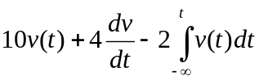

Assume that the value of the integral is zero at t = –∞.

